MICROPROJECT

Management (22509)

Year 2021-22



**PROJECT TOPIC – Management at TATA MOTORS**

**PART A – Micro-Project Proposal**

## Management at TATA Motors

#### 1.0 Brief Introduction

In This micro project I am going to make a detailed report on Management at TATA Motors

* 1. **Aim of the Micro-Project** (in about 1 to 2 Sentences)
     1. The main of this project is to understand the Management at higher level
     2. Understand the working structure of top tech companies
     3. Study the Ethics and principles followed at the higher level
     4. Understand the Managerial skills
     5. Conclude the best techniques and skills in practice

#### Intended Course Outcomes

* + 1. Use basic management principles to execute daily activities
    2. Use principles of planning and organizing for accomplishment of tasks
    3. Use principles of direction and controlling for implementing the plans

#### 4.0 Literature Review

For the purpose of this Management project, we searched various sources. Prominent among them are google, you-tube, Wikipedia. Also took the help of our subject teacher in choosing one of the unique subjects. You-tube also helped us clear a lot of concepts regarding our project as well as also the Google.

We also checked out the official handles of the TATA motor company. We studied stats from some of the prominent sources from the google. We also took help of newspapers and magazines along with the help of YouTube. With the help of all these sources collectively we performed this project .

#### Proposed Methodology

* + 1. First searched information for the suggested micro -project.
    2. Collected information for the suggested topic.
    3. Started for the micro-project.
    4. Completed micro-project.
    5. Showed to respected teacher.
    6. Teacher suggested some changes.
    7. Done the changes into the project as told by teacher.

#### 6.0 Resources Required.

|  |  |  |  |  |
| --- | --- | --- | --- | --- |
| **S. No.** | **Name of Resource/material** | **Specifications** | **Qty** | **Remarks** |
| 1 | Computer System/Laptop | Inte I5 Processor8 GB RAM 512 GB SSD | 1 | - |
| 2 | IDLE | Python IDLE 3.9 | 1 | - |

* 1. **Action Plan** (Sequence and time required for major activities for 8 Weeks)

|  |  |  |  |
| --- | --- | --- | --- |
| **S. No.** | **Details of activity** | **Planned Start date** | **Planned Finish date** |
| 1 | Searched for topic of micro-project |  |  |
| 2 | Topic searched: -  1. Management at Typing Institute. |  |  |
| 3 | Discussed with teacher about the topic |  |  |
| 4 | Teacher approved Project |  |  |
| 5 | Created prototype of our project |  |  |
| 6 | Started |  |  |
| 7 | Made a schedule |  |  |
| 8 | Started to collect the required resources |  |  |
| 9 | Completed |  |  |
| 10 | Showed models to teacher and she suggested some changes |  |  |
| 11 | We made the suggested changes |  |  |
| 12 | Teacher approved |  |  |

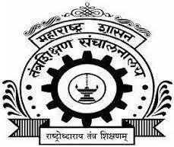CERTIFICATE

# Maharashtra State Board of Technical Education, Mumbai

GOVERNMENT POLYTECHIC, SOLAPUR

**Subject: Management (22509 )**

***Topic: Management at Computer Training Institute***

**Guide: (Prof.Kadam S.P)**

### Submitted By:

|  |  |  |
| --- | --- | --- |
| **Roll No.** | **Enrollment No** | **Student Name** |
| 24 | 1900150267 | Yogesh Dharmasa Gangji |

Of Sixth Semester of Diploma in **Computer Technology** of institute **Government Polytechnic, Solapur (0015)** have completed the micro project work satisfactorily under the guidance of **Prof.Kadam S.P** in the academic year 2021- 2022 as prescribed in the I -Scheme curriculum

Project guide H.O.D Principal

**(Prof.Kadam S.P)**

# Acknowledgement

We wish to express our profound and sincere gratitude to our guide **Prof. Kadam S. P,** who guided us in the structure of micro project as well as some main points in that micro project also they cleared our all doubts about micro project. We are Indebted to his constant encouragement, co-operation and help. It was his enthusiastic support that helped us in overcoming various obstacles in the project.

We would also like to express our thankfulness to our beloved Principal as well as HOD and other faculty members of our Third-year department for extending their support and motivation

Finally, we completed our micro project that regarding to our syllabus as well as department, Once more thanks for all Group members, Respected **Prof. Kadam S.P, HOD**, **Principal** and other Faculty Members who helped us in the micro project completion.

Index

|  |  |  |
| --- | --- | --- |
| **Sr.no** | **Topic** | **Page no** |
| 1 | **Rationale** |  |
| 2 | **Aim** |  |
| 3 | **Course Outcomes** |  |
| 4 | **Literature Review** |  |
| 5 | **Conclusion & Reference** |  |

## Rationale

In this project, I made a detailed project report on Management at Computer Training Institute which will be helpful to learn the management at large scale organizations. It will be much beneficial to us for understanding management by this live example of TATA Motors

## AIM

* + 1. The main of this project is to understand the Management at higher level
    2. Understand the working structure of top tech companies
    3. Study the Ethics and principles followed at the higher level
    4. Understand the Managerial skills
    5. Conclude the best techniques and skills in practice

## Course Outcomes

* Use basic management principles to execute daily activities
* Use principles of planning and organizing for accomplishment of tasks
* Use principles of direction and controlling for implementing the plans

**Literature Review**

## Tata motor

#### Introduction

**Tata Motors Limited** is an Indian multinational automotive manufacturing company, headquartered in the city of Mumbai, India which is part of Tata Group. The company produces passenger cars, trucks, vans, coaches, buses, luxury cars, sports cars, construction equipment.

Formerly known as Tata Engineering and Locomotive Company (TELCO), the company was founded in 1945 as a manufacturer of locomotives. The company manufactured its first commercial vehicle in 1954 in a collaboration with Daimler-Benz AG, which ended in 1969. Tata Motors entered the passenger vehicle market in 1988 with the launch of the TataMobile followed by the Tata Sierra in 1991, becoming the first Indian manufacturer to achieve the capability of developing a competitive indigenous automobile. In 1998, Tata launched the first fully indigenous Indian passenger car, the Indica, and in 2008 launched the Tata Nano, the world's most affordable car. Tata Motors acquired the South Korean truck manufacturer Daewoo Commercial Vehicles Company in 2004. Tata Motors has been the parent company of Jaguar Land Rover since the company established it for the acquisition of Jaguar Cars and Land Rover from Ford in 2008.

**Products of TATA Motor**

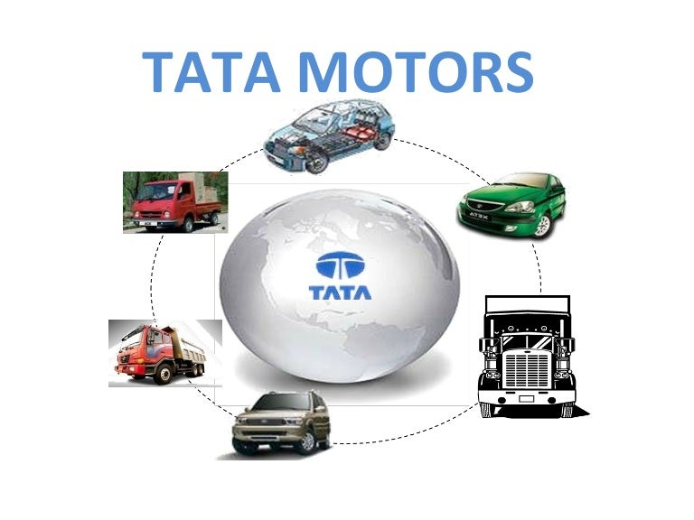

## Planning

**Vision**

By FY 2024, we will become the most aspirational Indian auto brand, consistently winning, by

* Delivering superior financial returns
* Driving sustainable mobility solutions
* Exceeding customer expectations, and
* Creating a highly engaged work force

**Mission**

We innovate mobility solutions with passion to enhance the quality of life.

#### Goals of Tata Motor

#### 

* + The Goal of Tata Motors is to provide good and efficient car with all people at reasonable price.
  + Tata Motors, a Company that cares about the future..... True to the tradition of the Tata Group.
  + Tata Motors is committed to letter & sprite to corporate social responsibility as well as economical interests of their shareholders who have invested in Tata Brands.
  + Tata Motors concerns in Manifested by a dual approach:
    - Reduction of environmental pollution and regular pollution control drives.
    - Restoring of ecological balance.

#### Short Term Goals

* + Liquid funds & Ultra short-term funds are ideal for investment horizons of up to 1 year. only high-rated investments in case of liquid funds.40 million customer bases across distribution businesses by FY26
  + Fixed maturity plans (FMPS) are close-ended schemes that invest in debt instruments having maturity from 30 days to 5 years.

#### Long Terms Goals

* + Diversified Equity funds /ELLS
  + Large/small/medium cap funds
  + Provide standerds cars for a customer
  + Leveraging data analytics to deliver customized solutions and Value- Added Services (VAS) to customers

#### TATA Motor Business Strategy

Tata Motors does not follow a single marketing approach or formula but it believes that all members of the community should be served. [Brand](https://www.marketing91.com/what-is-a-brand/) targets crowd from the rural part to the metros with its offerings varying from NANO to [Jaguar](https://www.marketing91.com/swot-analysis-jaguar/) [Land Rover](https://www.marketing91.com/marketing-mix-land-rover/) segment.

It targets anyone above 4 Lakh p.a. salary, millennial employed as professionals, managers and all those looking to switch from 2-wheeler to 4-wheeler. The age bracket for brand’s offering varies from 21-65 years with all Middle class. Upper middle class, High class and Affluent class in its [target](https://www.marketing91.com/swot-analysis-target/) category.

Tata Motors offers products such as Tata ACE a mini truck mainly used for agriculture transport purpose, [Tata NANO](https://www.marketing91.com/swot-tata-nano-failed-deliver/) for the middle class, Tata Indica and [Indigo](https://www.marketing91.com/marketing-strategy-of-indigo-airlines/) for commercial purposes and Jaguar in the high-class segment thus creating the image that there’s something for everyone in its huge line of offerings.

Differentiated [targeting](https://www.marketing91.com/how-to-make-a-targeting-strategy/) [strategy](https://www.marketing91.com/marketing-and-strategy-models-and-concepts/) is used by Tata Motors to target the customers and satisfy their [needs](https://www.marketing91.com/needs-wants-and-demands/) and wants.

#### Types of Plans Used by TATA motor Operational Planning

This type of pla nni ng typically describes the day-to-day running of the company. Operational plans are often described as single use plans or ongoing plans. Ongoing plans include policies for approaching problems, rules for specific regulations and procedures for a step-by-step process for accomplishing particular objectives.

**products**

* Cars and Sports Utility Vehicles
  + Electrical
  + Fuel
* Trucks & Buses
* Defense

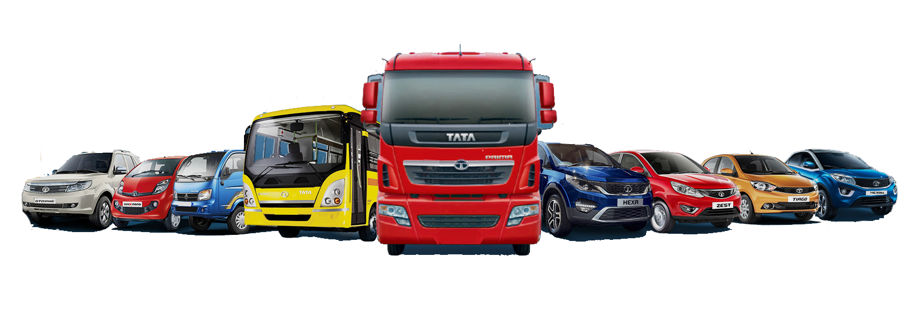

#### Strategic Business Planning

#### FOCUS ON NEW PRODUCT DEVELOPMENT

To develop a range of exciting and contemporary products and services across the PV and CV segments to match and surpass customer expectations

* Producing and delivering vehicles that create experiences, which customers love, for life
* Embracing technologies on ACES while delivering products of the highest quality
* Delivering a fully emissions-compliant portfolio
* Moving towards Modular Longitudinal Architecture (MLA) - scalable

**Looking ahead**

* TML is leveraging modular approach state-of the-art architectures both in CV and PV, whiledeveloping a number of new products and variants to enhance the range of choices for its expanding customer base.
* The Company is introducing contemporary and value-added features and technologies to increase the product appeal, safety and passenger comfort.
* TML is actively working on alternate propulsion systems, including zero-emission technology, especially in EVs for certain applications.

**Key initiatives and actions**

* Shipments to ASEAN doubled in FY18 as compared to last year, making it

the fastest growing region.

* In FY18, the Company successfully bagged several prestigious orders,

including 250 units Xenon pickups, 200 units of LPTA 715 from the

Myanmar armed forces,

#### Contingency Planning

Contingency plans are made when something unexpected happens or when something needs to be changed. Business experts sometimes refer to these plans as a special type of planning.

#### Rapid technology change

There is a paradigm shift in the automobile marketplace with rapid advances being made in new technologies such as electrification and autonomous cars, among others

#### Mitigation strategy

* + We continue to invest substantially in R&D and also continue our strategic focus on key technology areas, including autonomy, connectivity and electrification, with the aim of launching our products ahead of our competition.
  + We are working towards developing high-performance EVs, investing in development programmes to reduce fuel consumption by using lightweight materials, reducing parasitic losses through the driveline and improving aerodynamics.

**2 )Evolving customer demands**

Customer preferences, especially in mature markets, are trending towards smaller and more fuel-efficient cars and environment-friendly vehicles. In many markets, these preferences are driven by customers’ environmental concerns or increases in fuel prices.

#### Mitigation strategy

* + - TML and JLR are developing new models of vehicles in various segments with different capabilities.
    - TML developed and launched India’s first bio-methane engine for buses; Tata Nexon, an award-winning compact SUV and the XL range of small commercial cargo vehicles in India on the ACE platform.
    - JLR launched the I-PACE, a fully electric premium sedan, successfully electrified the Range Rover and the Range Rove Sport models and introduced the premium SUV Range Rover Velar.

#### 3)Diesel uncertainty

Adverse public perception of diesel-powered vehicles mainly driven by the media and government policy has precipitated a fall in diesel sales, primarily in the UK and Europe. It has also created uncertainty for customers, which could further impact future sales.

#### Mitigation strategy

* + We are committed to the introduction and expansion of our electrified fleet across the product portfolio and the continued refinement of our internal combustion engines and production flexibility in our Engine Manufacturing Centre.

#### 4) Information and cyber security

New and emerging technologies bring unprecedented threats to internet-connected devices, including vehicles. Recent global hacking incidents impacting the geo-political environment indicate an increase in the motivation to instigate cyber attacks.

#### Mitigation strategy

* + Both TML and JLR strive to implement consistent security policies and procedures while educating staff, vendors and suppliers to embed best practices. The Companies do this by implementing internal tools to detect and mitigate the current and emerging cyber security threats.

#### TATA Motor Polices

Following Policies are followed by Company

* + Advocacy Policy
  + Safety & Health Policy
  + Environmental Policy
  + Quality Policy
  + Sustainability Policy
  + Audit Committee Charter
  + Whistle Blower Policy
  + Terms of Appointment of IDs
  + Corporate Social Responsibility Policy
  + Policy on Related Party Transaction
  + Tata Code of Conduct for Non-Executive Directors and Independent Directors
  + Policy for Determining Material Subsidiaries
  + Familiarization Programmed for Independent Directors
  + Content Archiving Policy
  + Policy on Determination of Materiality for Disclosure of Events or Information
  + Dividend Distribution Policy
  + Environmental Procurement Policy
  + Climate change Policy
  + Privacy Policy
  + Code of Corporate Disclosure Practices

### Organizing

ORGANIZATIONAL STRUCTURE

Tata Motors has a Matrix Organizational Structure with both heads of functions (Human Resources head, Marketing head, Chief Financial Officer) as well as heads of vehicle divisions (Passenger Vehicles Head, Commercial Vehicles Head, Advanced Engineering Head) forming part of the top management of the company. It is through the collaboration of the various departments that day to day operations take place. Each Head of Division/Function is solely responsible for performance of their area of work.

Tata Motors has a Board of Directors consisting of 9 members from different parts of the Tata Group with Mr. Cyrus Pallonji Mistry as their Chairperson.

Mr. Guenter Butschek serves as the CEO and the MD of the company. All top level management in the company(such as Chief Financial Officer, Human Resources Head, Chief Information Officer, Secretary, Heads of Vehicle Divisions, etc.) report to him directly.

.

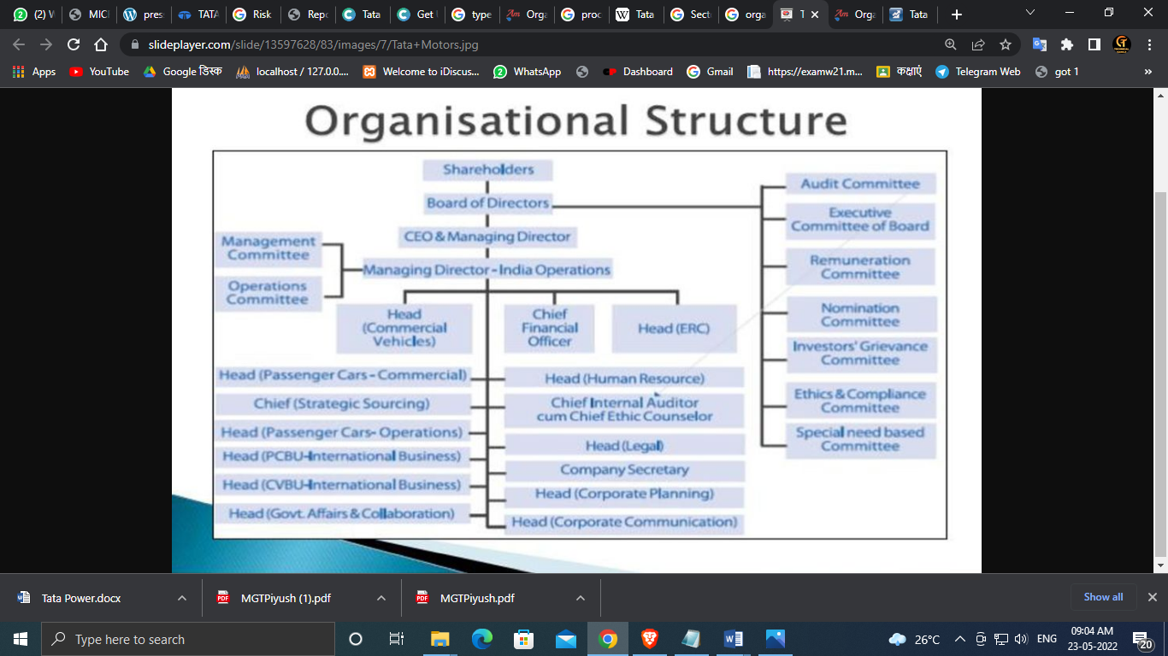

Departments in TATA Motor

* Tata Motors Cars.
* Tata Daewoo.
* Tata Hispano.
* Jaguar Land Rover.
* TML Drivelines.
* Tata Technologies.
* European Technical Centre.
* Manufacturing
* Accounts
* Advocacy
* Ash Utilization Services
* Aviation
* B2G Projects
* B2G Sales
* Billing
* Biodiversity
* Business Development
* Business Excellence
* C&I Maintenance
* Cell Process Engineering & Technology
* Cell Production
* Clean Technology
* Coal Handling Plant
* Coal Logistics
* Coal Procurement Group
* Commercial
* Commissioning & O&M
* Common Services
* Community Relations
* Company Secretary
* Consumer Business
* Consumer Engineering
* Consumer Marketing
* Consumer Sales
* Contracts & Procurement
* Contracts Management
* Contracts, Procurement & Logistics
* Control and Planning
* Core Technology and Diagnostics
* Corporate Affairs
* Corporate Communication
* Corporate Communications
* Corporate Monitoring Group
* Corporate Relations Group
* Costing & Project Finance
* Customer Acquisition
* Customer Relation
* Customer Service
* Demand Side Mgmt.
* Distribution Capex
* Distribution O&M
* Distribution Planning & Training
* Distribution-Cable
* Electrical Construction
* Electrical Maintenance
* Employee Services & Administration
* Encroachment
* Environment & Climate Change
* Erection
* Estate
* Expansion Projects
* Expediting Cell
* Finance
* Finance & Accounts
  + Financial Concurrence Group
  + Fire
  + Fuel Technology Management
  + HSSE
  + HSSE & Sustainability
  + Headworks
  + Horticulture
  + Human Resources
  + IT
  + Industrial Relations
  + Insurance
  + Internal Audit
  + International Sales
  + Investor Relations
  + Land Acquisition
  + Legal
  + Liaoning
  + Maintenance Planning
  + Manufacturing
  + Marketing
  + Materials
  + Mechanical Construction
  + Mechanical Maintenance
  + Medical Services
  + Meter Installation Team
  + Meter Management Group
  + Meter Reading & Joint Meter Reading
  + Module Engineering
  + Module Maintenance & Plant Engineering
  + Module Production
  + Office of CEO
  + Operations
  + Payroll & Trust Management
  + Performance & Efficiency Cell
* Performance Analysis Group
* Performance Assurance & Call Center
* Planning & Controls
* Policy Affairs & Advocacy
* Procurement
* Product Engineering
* Production Planning
* Project Delivery & Commissioning
* Project Development & Costing
* Project Engineering
* Project Engineering - Large Projects
* Project Engineering - Rooftop
* Project Execution - Large Projects
* Project Management
* Project Planning
* Projects
* Projects Sales
* Quality
* Quality Assurance, Inspection & Testing
* Quantity Surveying
* Regulations
* Revenue Recovery & Revenue Assurance
* Risk Management
* Rooftop Projects
* Rooftop Projects, LP Commissioning & O&M
* SAP-Center of Excellence
* Safety
* Sales
* Secretary

#### Factory Structure of TATA Motors in India.

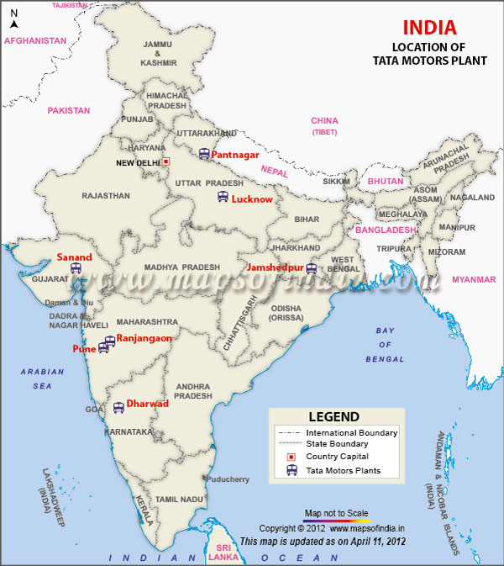

## Directing

* + Supervision

Supervision is a process that involves a manager meeting regularly and interacting with worker(s) to review their work. It is carried out as required by legislation, regulation, guidance, standards, inspection requirements and requirements of the provision and the service. The purpose is to monitor tasks and workload, solve problems, support workers in dealing with complex situations and moral and ethical dilemmas and to promote staff development

In TATA Motors Top Department head or manager of department/ plant take meet of workers , engineers daily to supervise and give instruction to worker and engineer

* + Motivation

Motivation’ is the process of inspiring people in order to intensify their desire and willingness for executing their duties effectively and for co- operating to achieve the common objectives of an enterprise.

In other words, it means to induce, instigate, incite or prompt someone to a particular course of action for getting the results expected from him.

In TATA Motors Top Level management of plant take meet of lower management and workers , engineers once in every 2-3 year to motivate

.

* + Leaders

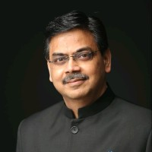

### Mr. Girish Wagh

#### Executive Director

Mr. Girish Wagh started his career at Tata Motors as a Graduate Engineer Trainee (GET) in 1992 after completing his Engineering from Pune University. Thereafter, he completed his Post Graduation in Manufacturing Management from the S P Jain Institute of Management and Research.

In his illustrious career of 29 years with Tata Motors, Mr Wagh has held several senior roles with increasing and complex responsibilities across both, Passenger Vehicle and Commercial Vehicle Business Units. Leading teams across multiple functions, he successfully delivered game changing projects including the Tata ACE - Mini Truck and the new generation cars including Nano, Bolt, Zest, Tiago, Hexa and Tigor.

For his excellent contribution to the automotive industry, Mr Wagh was recognized as the “Rising Star” by the Automotive News Europe in 2011 and was recently awarded with “CV Man of the Year” at the Apollo CV Awards 2020.

Mr. Wagh has been President and Head of Commercial Vehicle Business Unit - Tata Motors and a member of the Executive Committee (ExCom) since July 2017.

Mr. Wagh was appointed as an Additional Director and Executive Director of the Company w.e.f. July 1, 2021.

* + Communication

Main goals for External Communications:

* + Strengthen confidence in Tata Motor brand, management team and employees.
  + Support the business concept and strategies.
  + Meet expectations concerning Tata Motors compliance with legislation,

regulations and standards relating

* + to communication activities.
  + Facilitate recruitment of employees. Main goals for Internal Communications:
  + Contribute to the Tata Motors business objectives.
  + Enhance employees‟ knowledge about business objectives, strategies

and values.

* + Update employees on the Company and its developments.
  + Increase Company loyalty and teamwork

### Controlling

* Personal Observation

This is the most traditional method of control. Personal observation enables the manager to collect first-hand information. It is the simplest method to control organizational activities is that managers take round at the workplace and monitor the development of the work. It is the most effective, direct and oldest method of control. It also creates a psychological pressure on the employees to perform well as they are aware that they are being observed personally on their job. Any fault in performance can be spotted and corrected instantly. The personal observer accurately knows what is wrong and can take essential proceedings quickly. Thus, the managers can preserve work regulation among the employees, they can take immediate action to prevent resistance to control measures.

However, it is a very time-consuming exercise and cannot effectively be used in all kinds of jobs.

Observation on TATA Motors

Apart from its power distribution business The company operates 1,211 ckt.km (circuit kilometers) of transmission network in Mumbai and its suburbs.

It also has a joint venture (JV) with Power Grid Corporation of India Limited in the construction of 2,328 ckt.km double circuit transmission lines from Siliguri in West Bengal via Bihar to Mandola in Uttar Pradesh

Resurgent Power, a joint venture in which Tata holds a 26% stake, has obtained a Letter of Intent to acquire 100% shareholding in NRSS XXXVI, which is developing a 153 km transmission system.

Tata Power is one of 29-publicly listed subsidiaries of Indian multinational conglomerate Tata Group which has businesses from steel and vehicles to hospitality. As of 31 December 2021, Tata Group and its subsidiaries had a combined market capitalization of $314bn.

28

* Statically Analysis

Statistical analysis provides managers with the tools necessary to make sense of large quantities of data and to make ever more effective business decisions based on inferences drawn from data. Statistical methods may be broken into two broad categories— methods of description and methods of inference. Descriptive statistics methods consist of a variety of techniques—both mathematical and graphical—by which to organize and describe data. Two characteristics of great interest in data description are the central tendency and degree of variation in a given variable. For example, a manager might be interested in what the average earnings of a group of workers is or might be interested in knowing whether there is much variation in the diameter of items produced in a production run.

Key Matrix of TATA Motors

1. PE Ratio of Tata Motors is 42.80
2. Earnings per share of Tata Motors is 5.45
3. Price/Sales ratio of Tata Motors is 1.78
4. Price to Book ratio of Tata Motors is 2.80

#### Breakeven Analysis

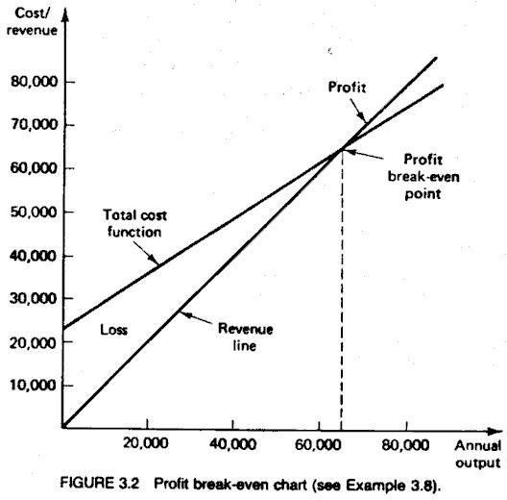A break-even analysis is a financial calculation that weighs the costs of a new business, service or product against the unit sell price to determine the point at which you will break even. In other words, it reveals the point at which you will have sold enough units to cover all of your costs. At that point, you will have neither lost money nor made a profit.

29

* Budgetary Control

Budgetary control is known as setting up a particular budget by management in order to know the variation between actual performance and budgeted performance of the company and it also helps managers in utilizing these budgets so as to monitor and control various costs within the particular accounting period.

Types Of Budget In TATA Motors

* Sales Budget
* Production Budget
* Cash Budget
* Capital Budget
* R&D Budget
* Transport Budget

30

## Staffing

To enable employees to perform at their full potential, it is imperative to create a work environment that is collaborative, enriching and fosters a culture of learning and growth.

Our HR strategy adopts a multipronged approach touching seven key facets that enable employee development and organizational success.

The alignment of our employees' individual values and aspirations with the Company's ideals is a central pivot that enables value generation for our customers, the society and the environment.

Employee Engagement at Tata Motors

* + Platforms that enhance qualitative employee engagement

Our work culture enables continuous dialogue with our employees. We actively listen to their needs, aspirations and ambitions, making their voices heard and their inputs valued, and thereby facilitating an open channel for two-way communication. We consciously seek feedback on any organizational changes and keep our employees adequately informed to ensure smooth transition.

* + Unique appraisals for enhanced performance

Our Performance Management is a key talent management process that drives a high-performance culture and helps create excellence by enabling achievement of organizational plans. All our employees, across all levels, received regular performance appraisal and feedback during the reporting period. The process involves setting the individual’s Key Result Areas (KRAs), which are cascaded from the strategic goals of the organization, cluster and divisions/ functions.

31

## Risk Management

The Committee operates as per its Charter approved by the Board and within the broad guidelines laid down in it. The Company has a Risk Management Policy in accordance with the provisions of the Act and SEBI Listing Regulations. It establishes various levels of accountability and overview within the Company, while vesting identified managers with responsibility for each significant risk.

The Board takes responsibility for the overall process of risk management in the organisation. Through Enterprise Risk Management Programme, business units and corporate functions address opportunities and the attendant risks with an institutionalized approach aligned to the Company’s objectives. The business risk is managed through cross-functional involvement and communication across businesses. The results of the risk assessment are thoroughly discussed with the Senior Management before being presented to the RMC.

The poor financial performance of the state Discoms (collection of tariffs in accordance with PPAs)

In renewables, creditworthiness and business continuity of the customer remains an issue

#### Mitigation strategy

* + Close monitoring of financial health of the Discoms through Discom Ratings by Ministry of Power
  + Sustained advocacy with distribution companies and regulatory bodies
  + Diversification of renewable portfolio across various procurers, tariff structures and states

#### Technology risk

Cyber security risk threatening data privacy and having potential to impede operational transactions

32

#### Mitigation strategy

* + Continuous enhancement in automated detection and preventive solutions to address evolving threats
  + Continued reinforcement of security policies and procedures
  + Enterprise-wide training and awareness programmed on information security
  + Inputs from Computer Emergency Response Team (CERT) and other private Cyber Intelligence agencies, and enhanced awareness of emerging cyber threats
  + Periodic testing to validate effectiveness of controls through Vulnerability Assessment and Penetration Testing
  + Regular internal and external audits
  + Investment in Cyber Insurance

#### Financial risk

Availability of cost -effective capital: availability of debt in terms of current level exposure of the banking sector to stressed asset

High leverage: Increased borrowings over last few years primarily due to losses in CGPL

Renewal of license of KPC mine in Indonesia

#### Mitigation strategy

* + Diversification of lenders base by reaching out to lenders who have not breached exposure limit, diversification to overseas borrowing, ECBs, ECAs, etc.
  + Monetization of non-core assets and other investments to deleverage
  + Advocacy with Indonesian government along with JV partners

33

#### Business risk

Availability of fuel for thermal plant at optimal cost

#### Mitigation strategy

* + Exploration of alternative coal sources, liaise with coal companies to understand their production and dispatch plan, reduction of coal consumption though operational efficiency

34

## Conclusion

Hence from this Micro project I learnt the various concepts in Management. Learnt how the management is done in real life. Learnt the management of TATA Motors

## Reference

|  |  |  |
| --- | --- | --- |
| **Sr.no** | **Reference** | **Remark** |
| 1 | Books | Nirali , Tech Knowledge |
| 2 | Internet | [https://courses.lumenlearning.com/boundless -](https://courses.lumenlearning.com/boundless-management/chapter/management-levels-and-types/) [management/chapter/management-levels-and-types/](https://courses.lumenlearning.com/boundless-management/chapter/management-levels-and-types/) |

35